BU.330.740 Large Scale Computing on the Cloud

**Lab 4. Computer Vision using Amazon Rekognition**

Learning Goal: practice using both Amazon Rekognition Demos and Custom Labels to implement variety of computer vision tasks, including label detection, facial analysis, face comparison, text in image, video analysis, and medical image classification.

**Taks 1: Brain tumor classification using Custom Labels.**

We will use a brain tumor dataset in this lab. This dataset is adapted from a Brain Tumor MRI collection on Kaggle <https://www.kaggle.com/datasets/masoudnickparvar/brain-tumor-mri-dataset?resource=download> , consists of Magnetic Resonance Imaging (MRI) scans, an important diagnostic tool that uses magnetic fields and radio waves to generate detailed images of the body’s internal structures—particularly useful for detecting and assessing brain tumors. While the original dataset included several specific tumor types (such as glioma, meningioma, pituitary tumors) as well as no tumor images, it has been simplified into two categories for this lab: tumor and non-tumor, with 84 images in each category.

1. Prepare. Download training_data.zip from Canvas, unzip and store them in a local folder.
2. Login into your AWS Academy account at <https://awsacademy.instructure.com/login/canvas>. Then please follow “*AWS Academy Learner Lab – Student Guide.pdf”* provided by AWS to launch **AWS Management Console**.

Note: “Start Lab” step may take long especially at the first time.

1. Go to Custom Labels. In **Search**, search for “rekognition”

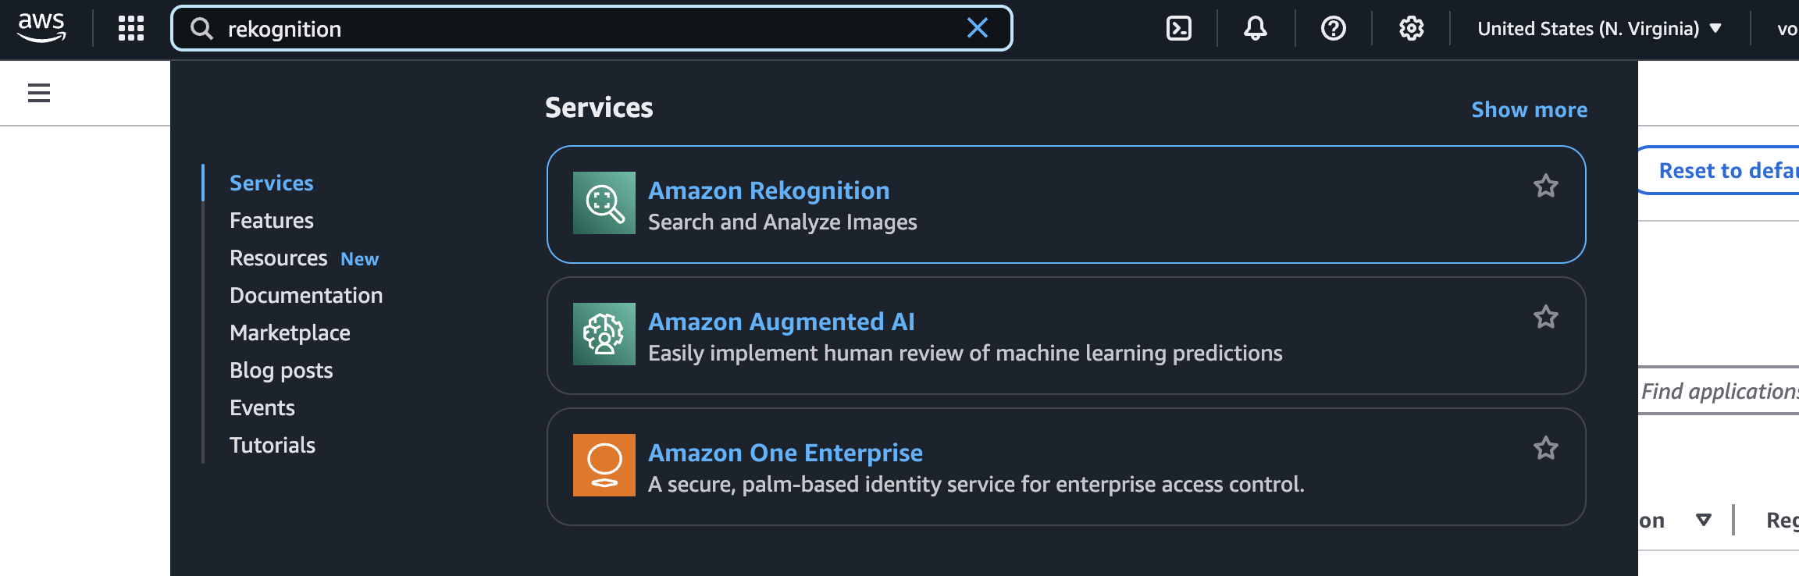

Choose **Use Custom Labels** in the left.

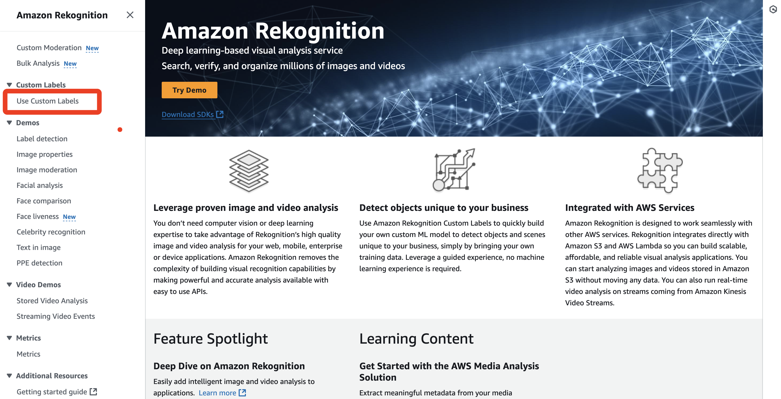

Choose **Get started**.

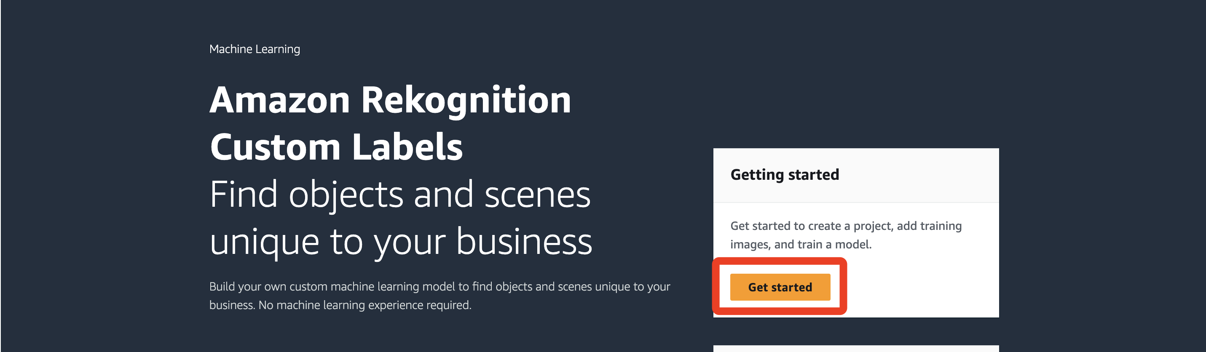

It will automatically create a S3 bucket to store the project file, choose **Create S3 bucket**.

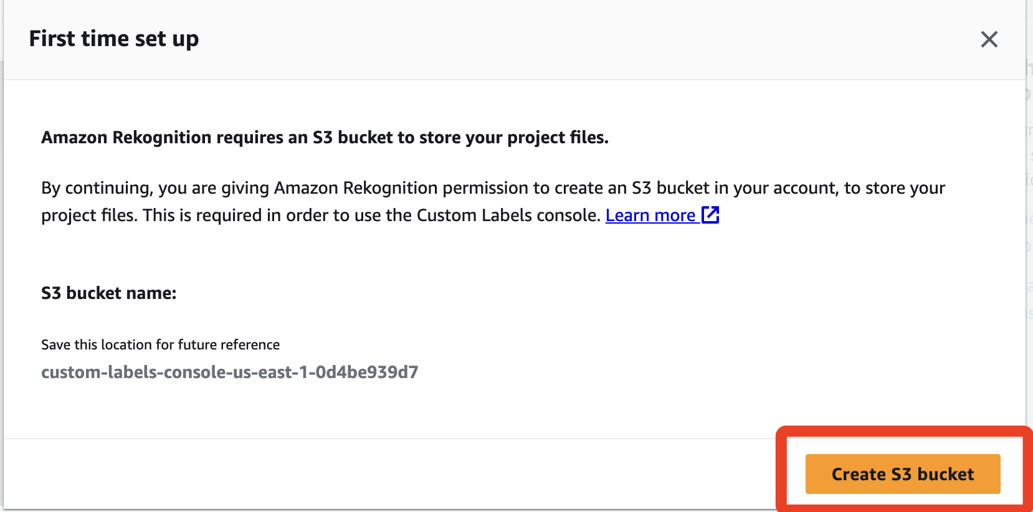

1. Upload Training data to S3 bucket. Go back to **AWS Management Console**, search for S3 to open the S3 console. There’s a new bucket that you just created, with the name ‘custom-labels-console-xx-xxx-xxxxxxx’. Choose that bucket, choose **Upload**, then choose **Add folder**, upload the training data you stored at the first step.

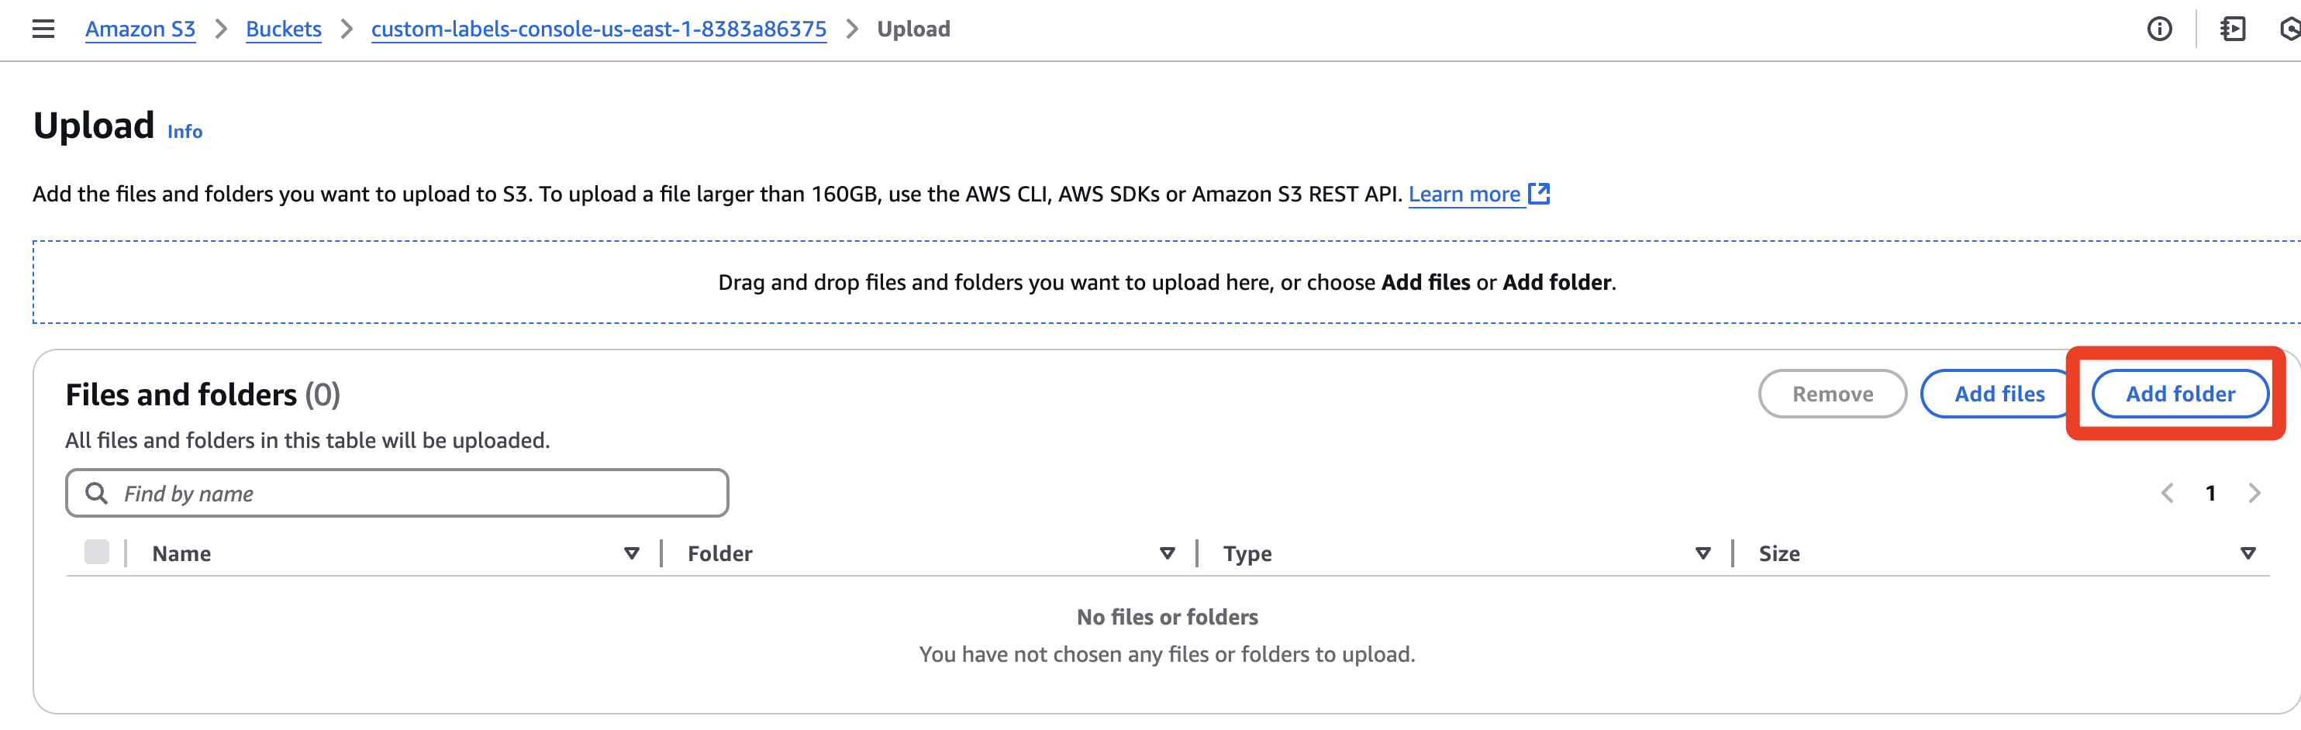

Scroll down and choose **Upload**

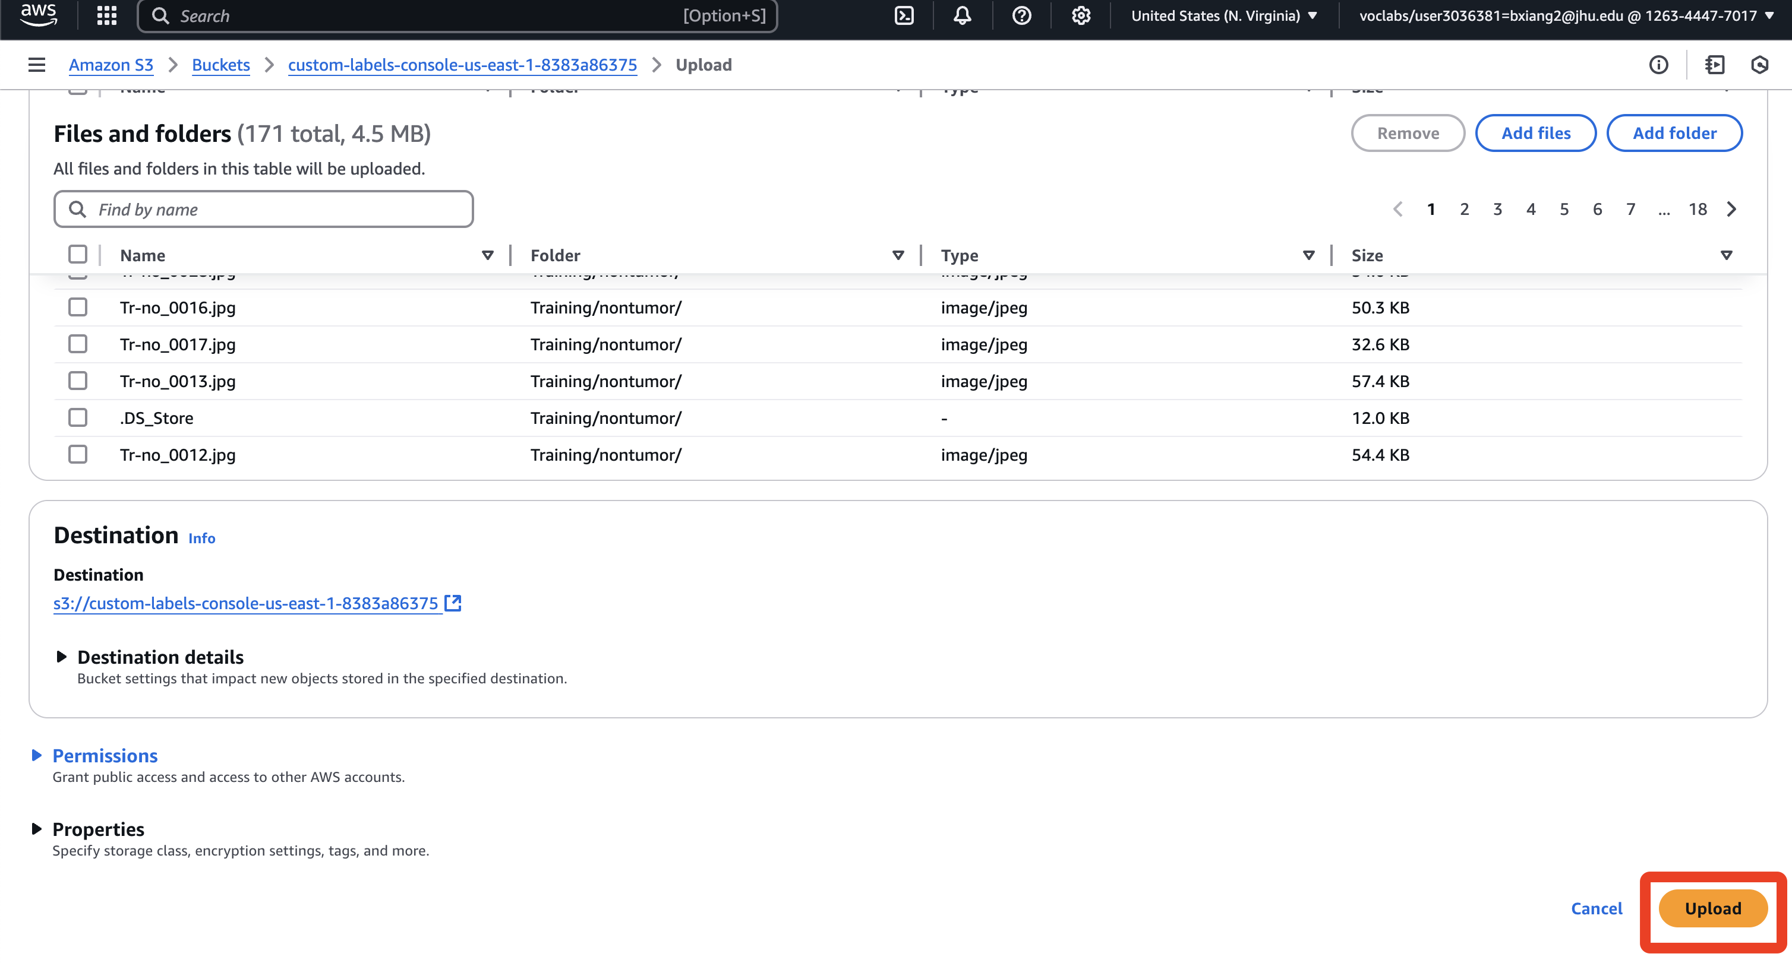

After a few minutes, you can see the notification of Upload succeeded. Choose **Close** to get back to the bucket, choose the **Training** folder that you just crated. In the Training folder, choose **Copy S3 URI**, paste it in your note or other files to save that URI, **we will use it later.**

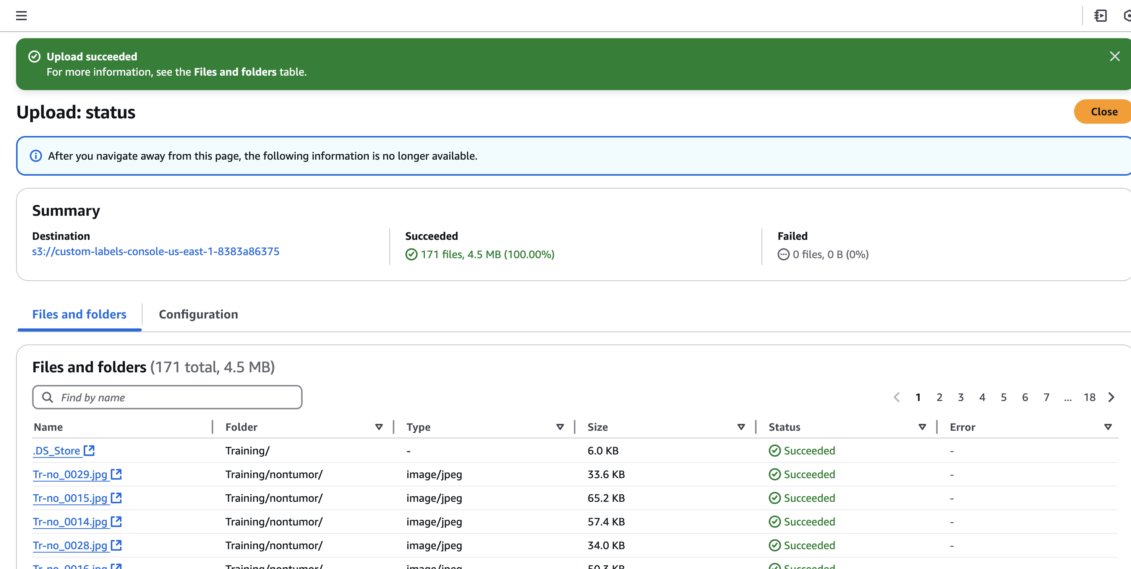

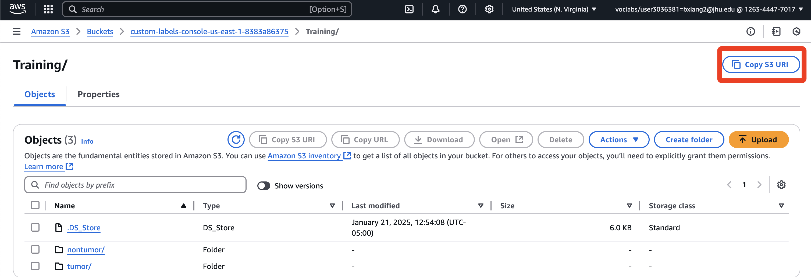

1. Train your model in the Custom Labels. Repeat Step 3: Go back to **AWS Management Console**, search for “rekognition” to open the Amazon Rekognition console. Choose **Use Custom Labels** in the left and choose **Get started**.

Choose **Projects** in the left.

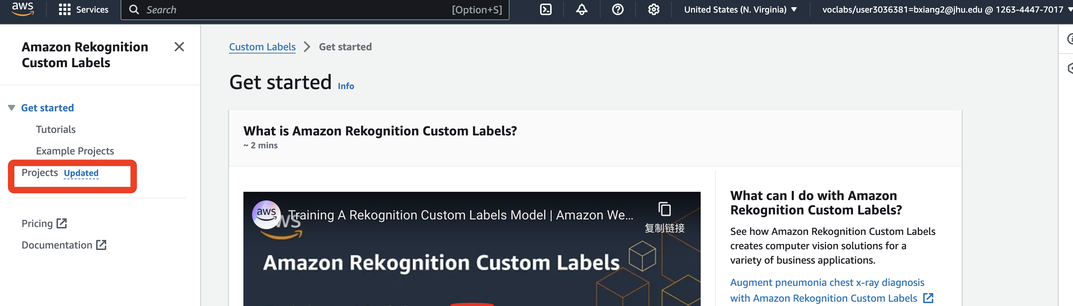

Choose **Create project**, then enter a **project name**.

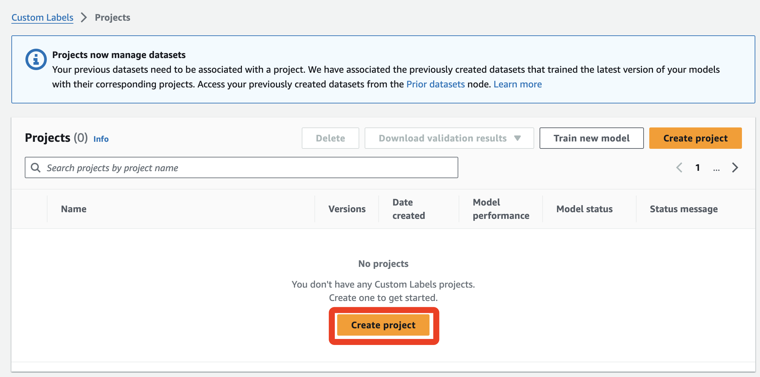

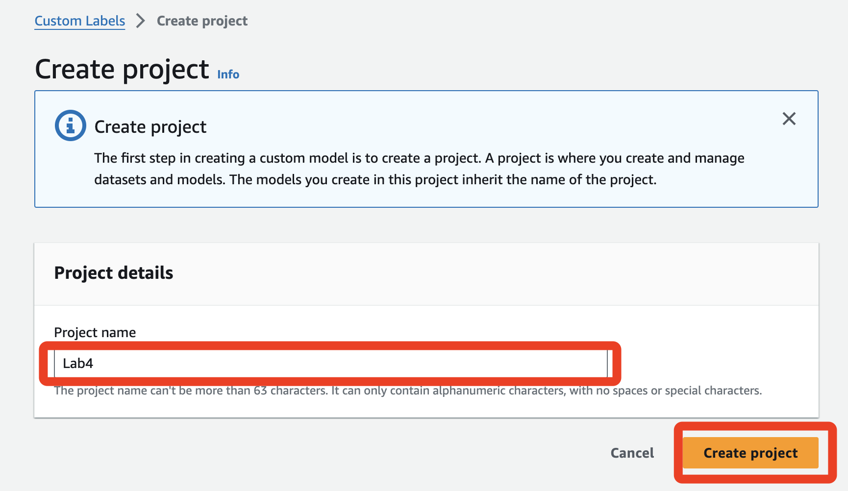

Choose **Create dataset**

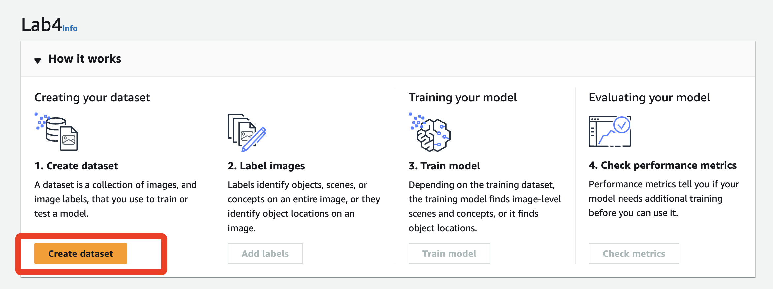

In the **Training dataset details** section, choose **Import Images from S3 bucket**.

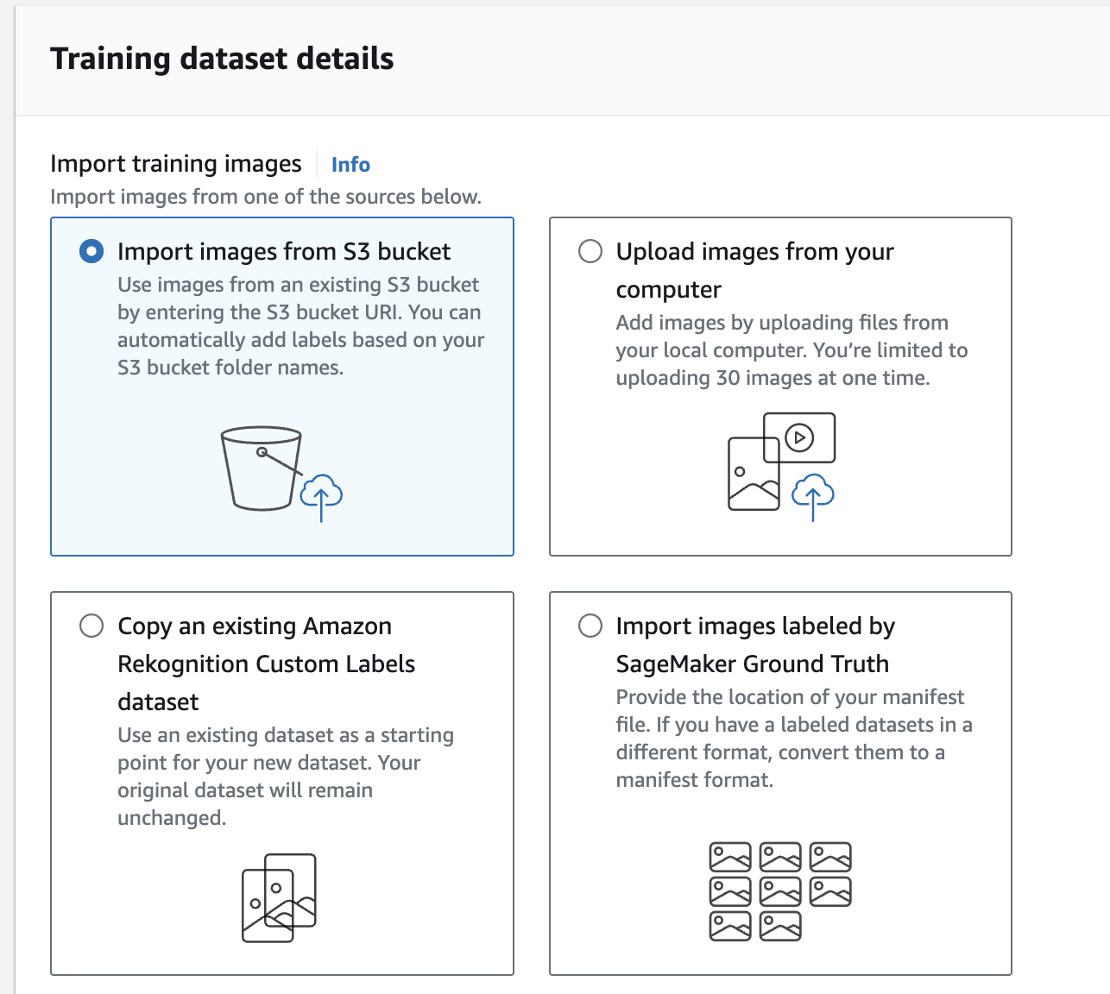

In the **S3 URI**, enter the S3 URI that you saved in the step 4.

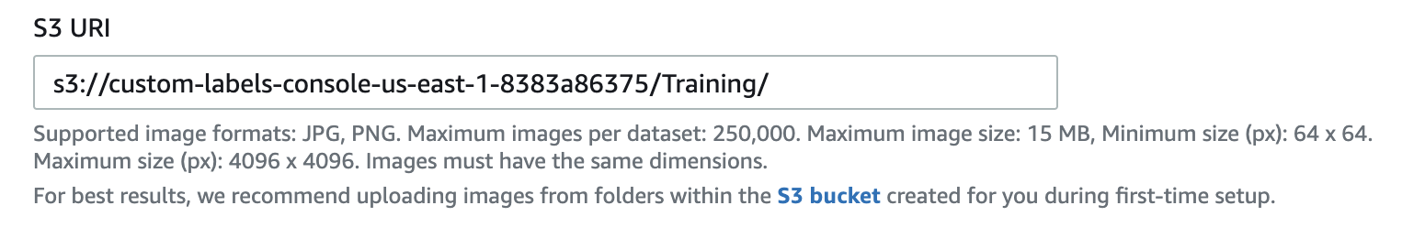

In the **Automatically labelling**, choose automatically assign image-level labels based on the folder name. The folder name will be the label of images in that folder.

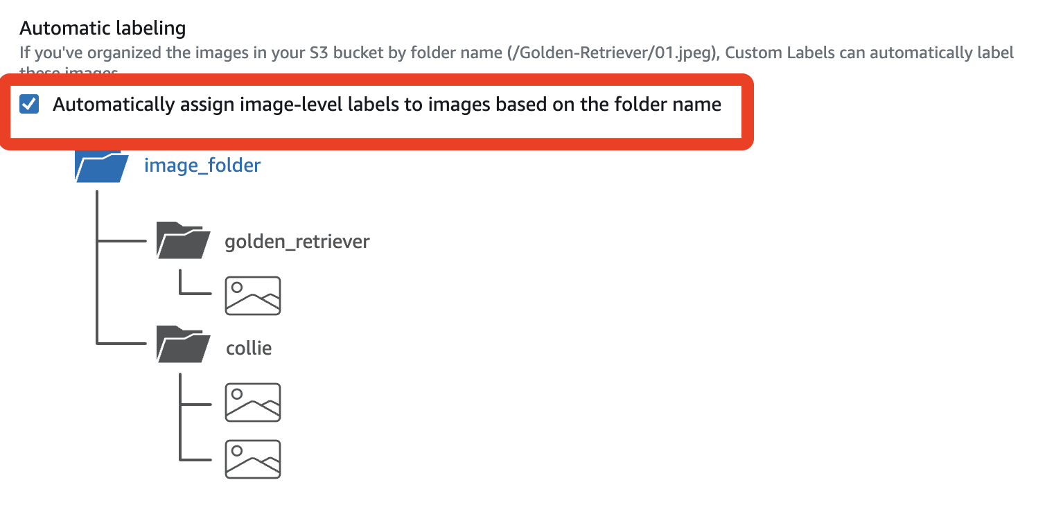

Choose **Create Dataset** in the right corner, after a few seconds, you can see the detail of your dataset. Choose **Train model**.

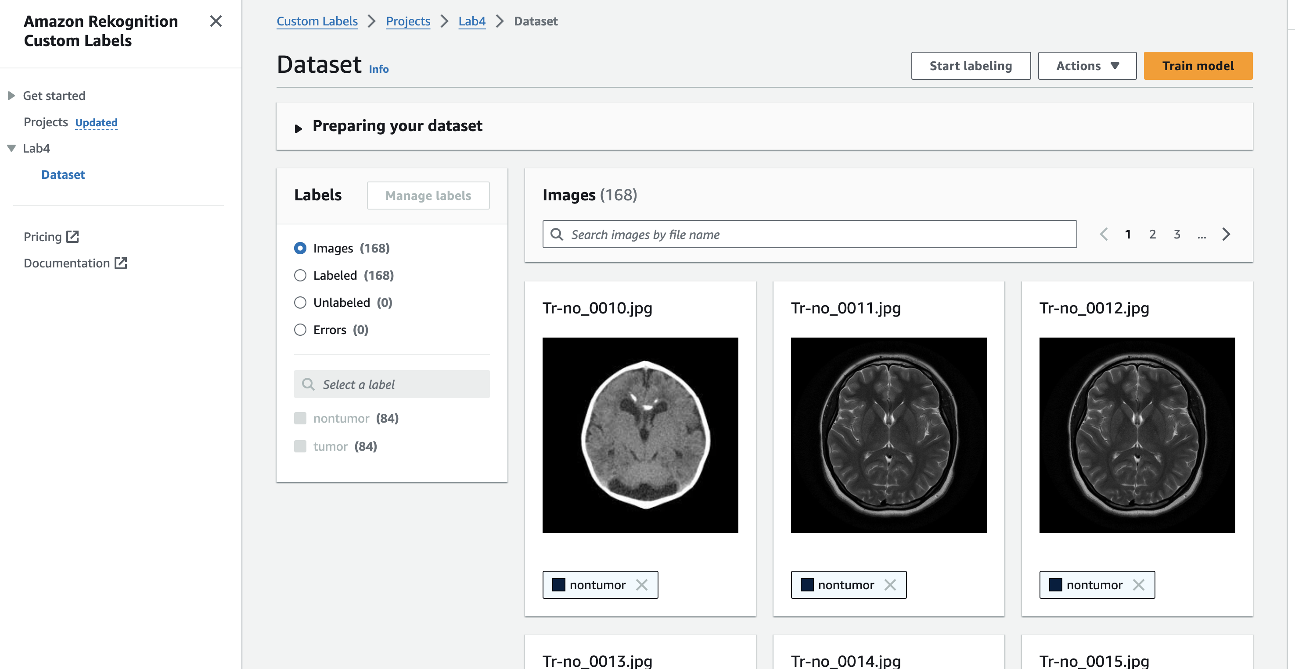

In the Train model page, choose project in the **Training details** section. Scroll down and choose **Train model** to start training.

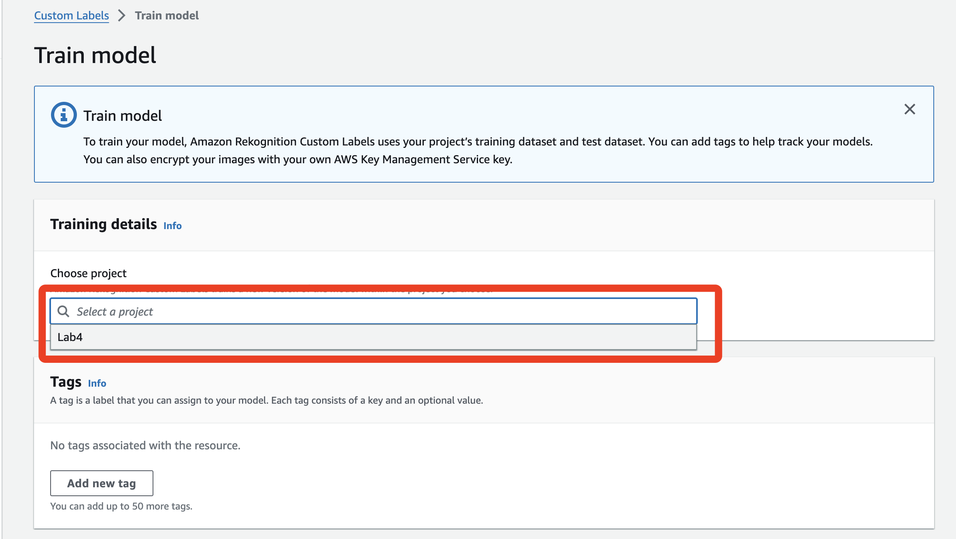

Then you can see your model in the project page. It is normal that the **Model status** shows TRAINING _IN_PROGRESS, it may take 20 – 30 minutes to train the model.

**Once the model begins training, you CANNOT delete or stop it. You can only train UP TO THREE MODELS at a time.**

**This means you have only three raining opportunities. If you use them all, you must wait for a model to finish training before creating a new one.**

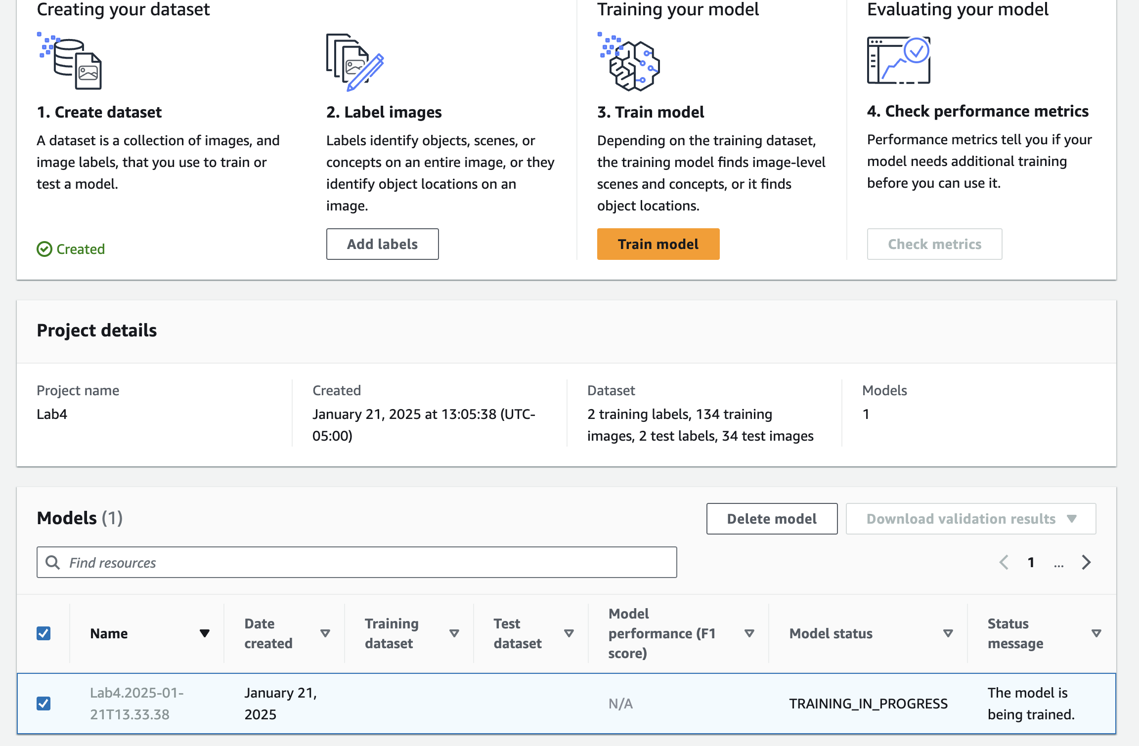

1. Check performance metric of your model. Once your Model status shows TRAINING_COMPLETED, you can click the name of your model to get the evaluation of your model.

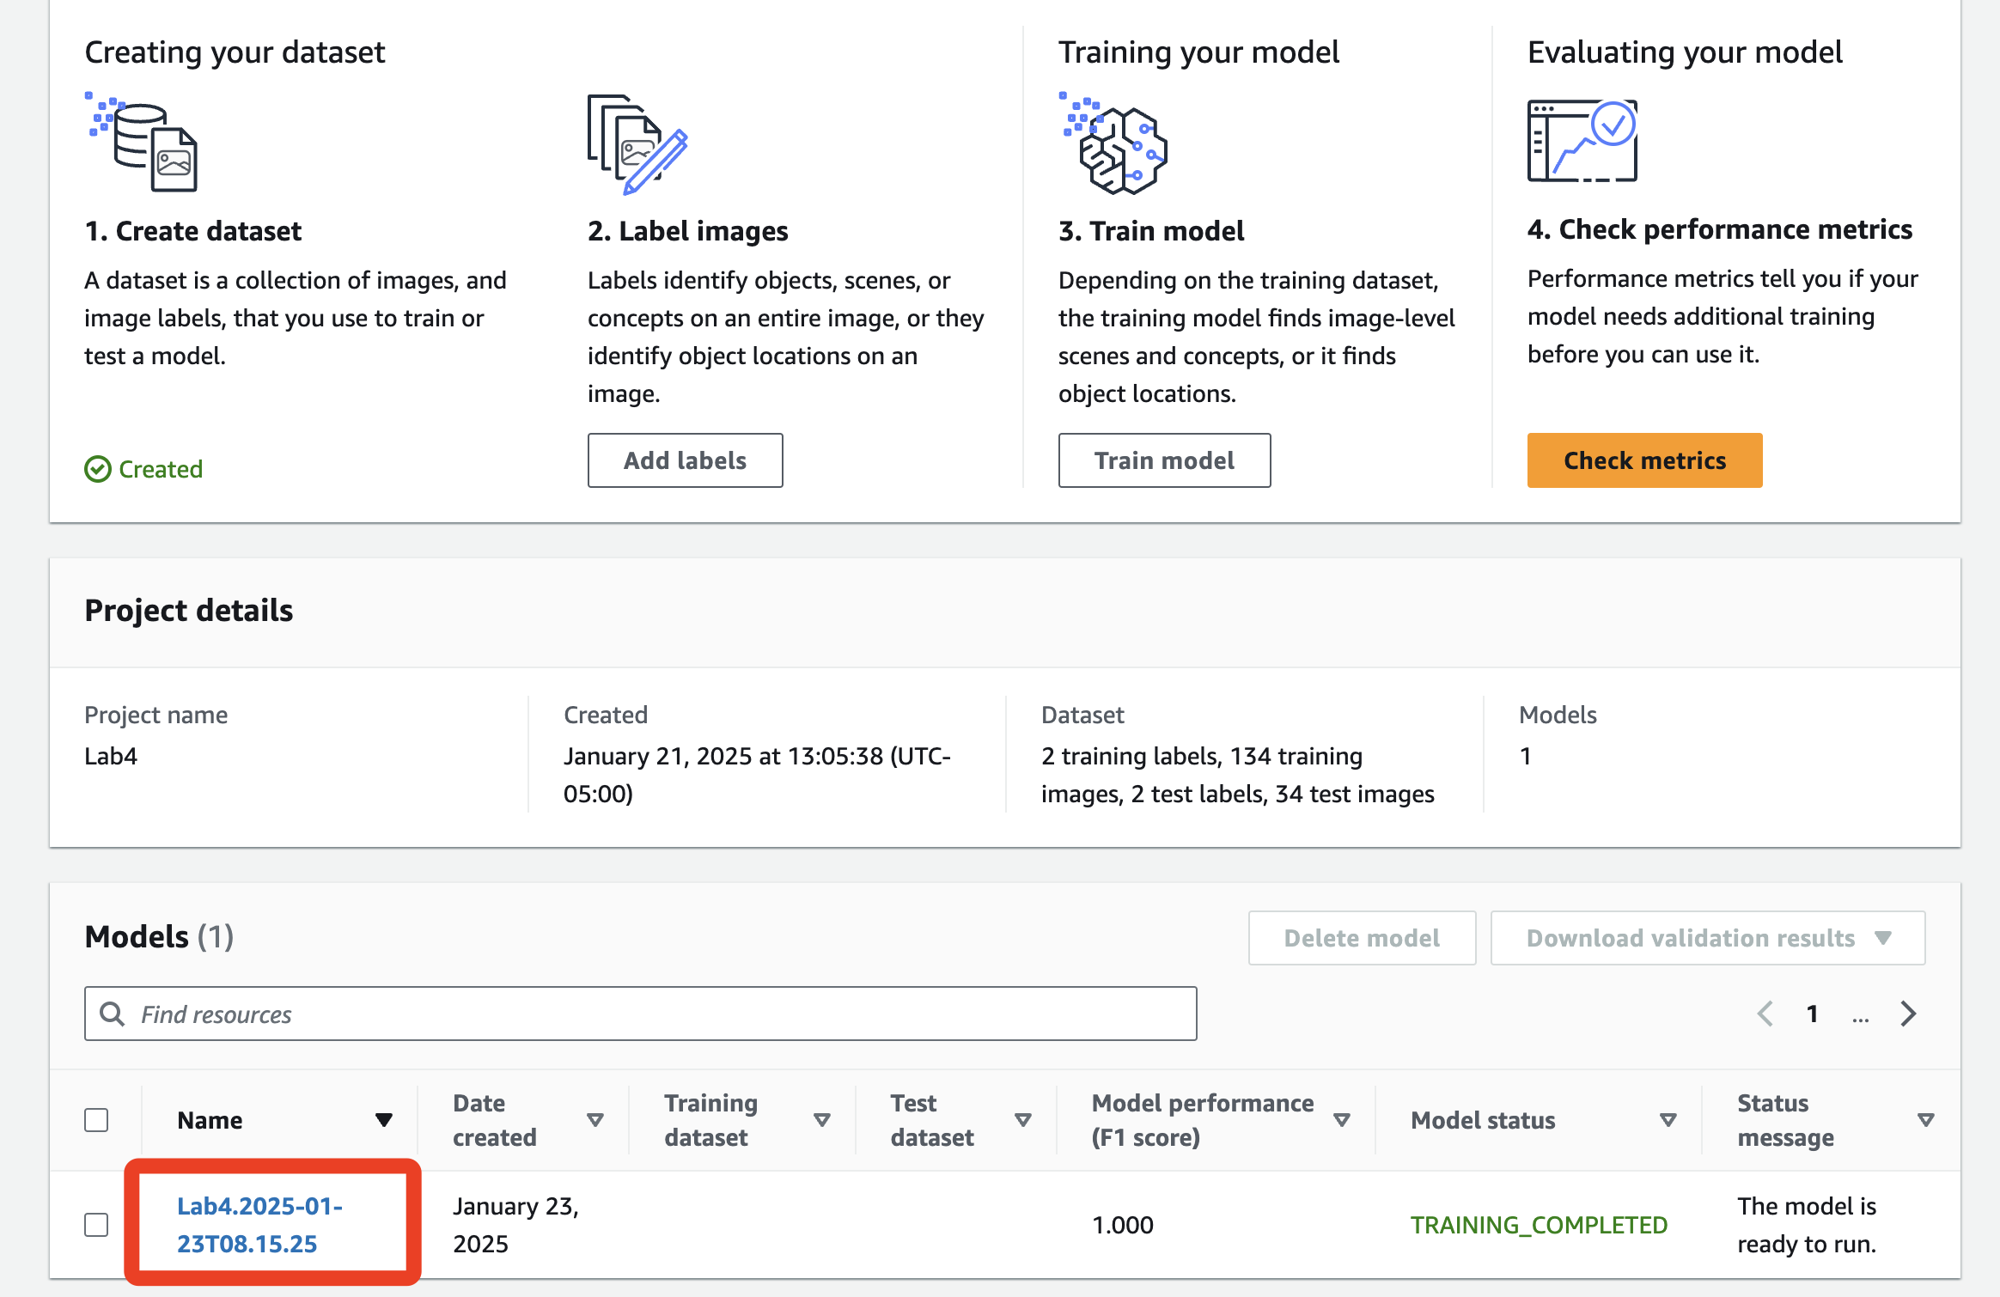

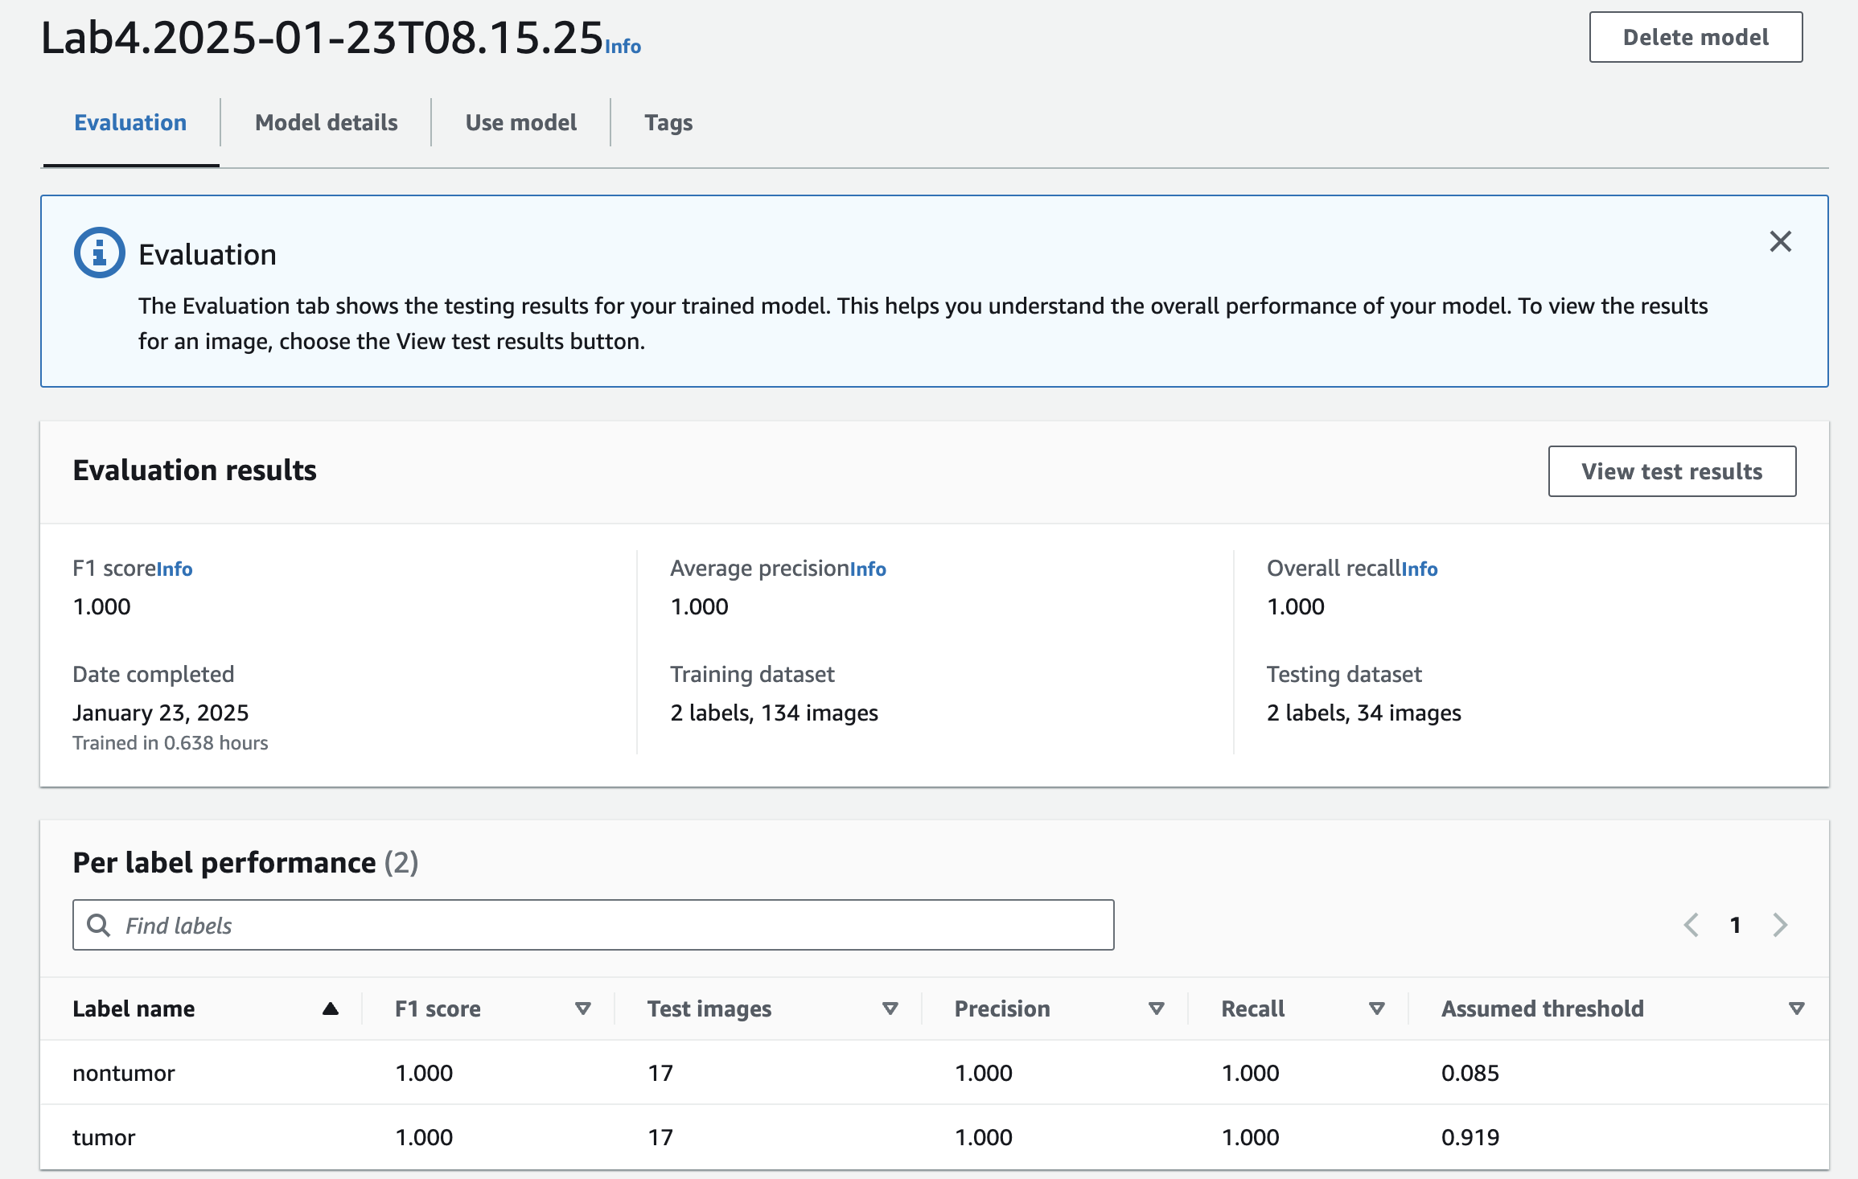

**Taks 2: Demos in Amazon Rekognition.**

1. Go to Amazon Rekognition. In **Search**, search for “rekognition”



In the left, you can see **Demos** and **Video Demos**.

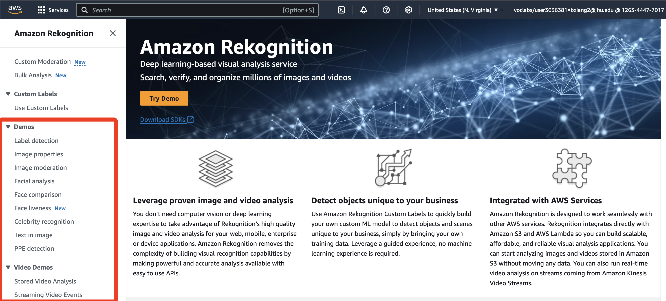

1. Practice on Label detection, Facial analysis, and Text in image. Choose any of these demos in the Amazon Rekognition console.

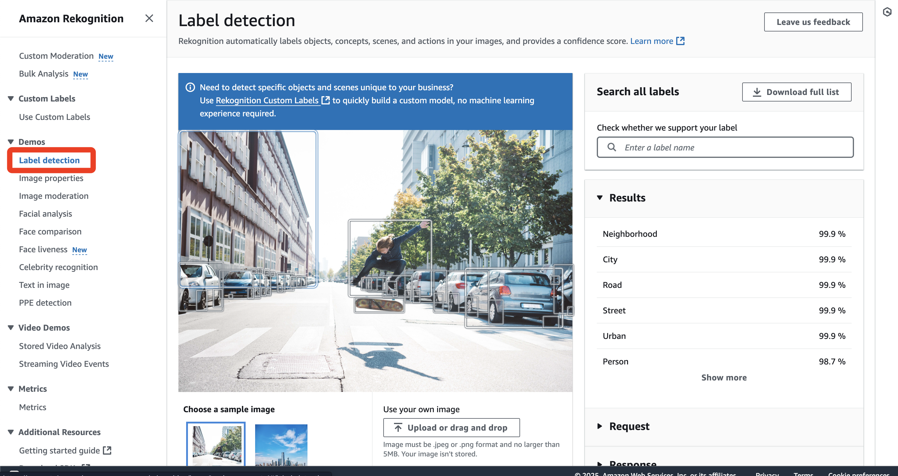

Drag and drop your own image into the central upload area to see the analysis results.

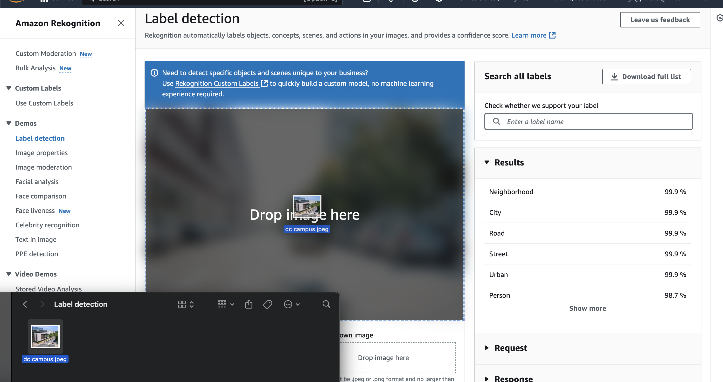

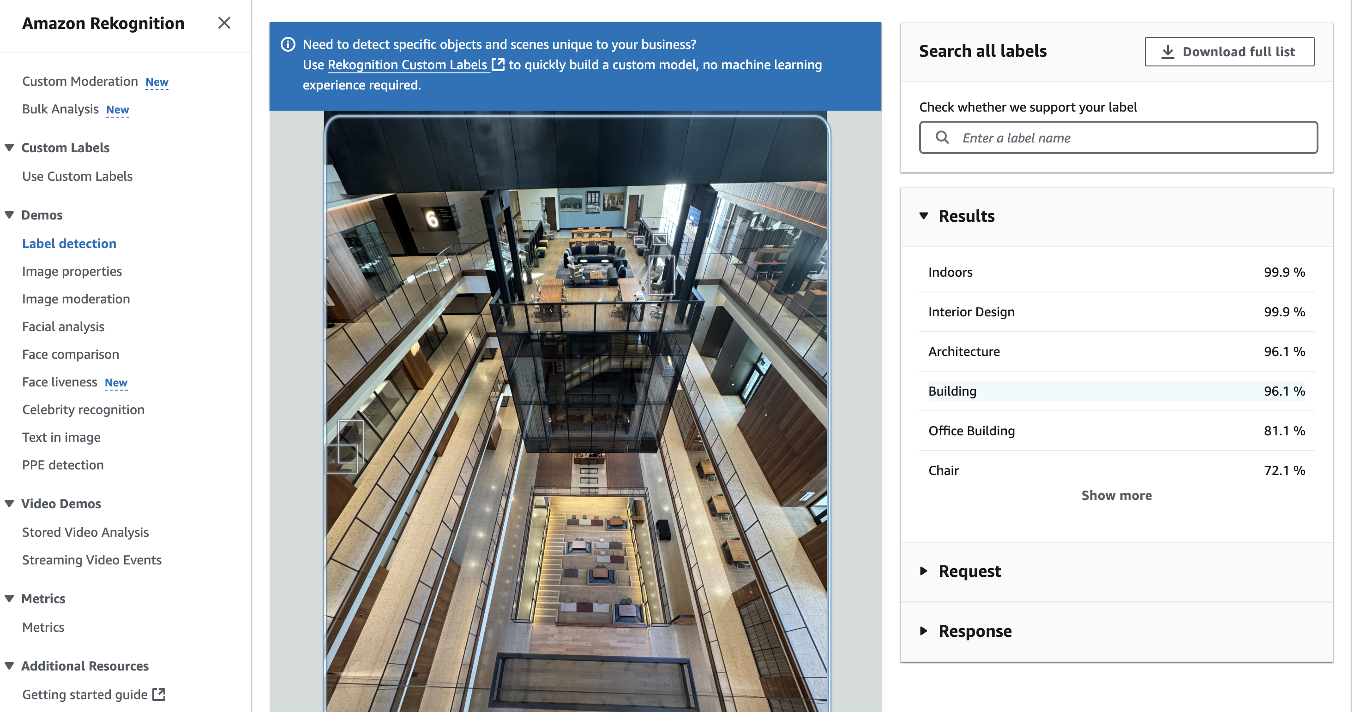

You can try as many images as you like, but remember that **your image must be in .jpg or .png format and no larger than 5MB.**

Reference:

<https://catalog.us-east-1.prod.workshops.aws/workshops/4a2a9a24-071d-4d96-b9be-0cc57b7db434/en-US>